Halloween Chichibu Ghost Town Ride Saturday 10/30/21
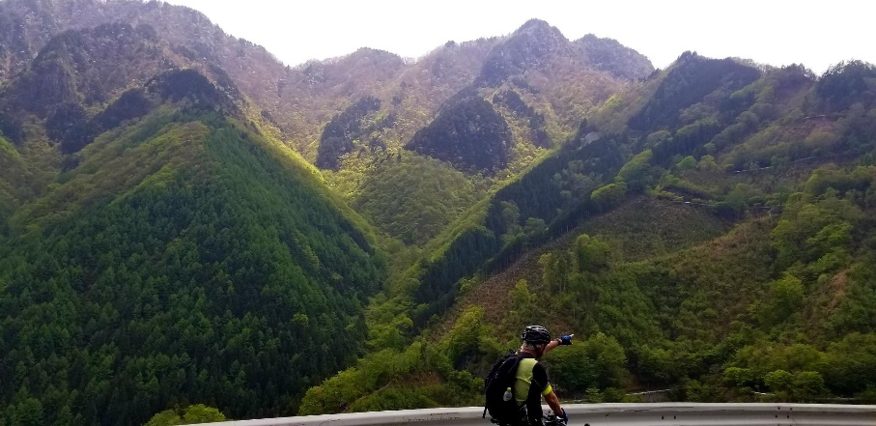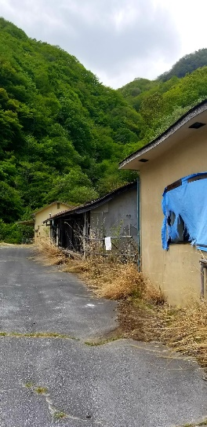
Overview: Halloween, cooler temps and fall colors means it’s time to head to the mountains of Chichibu for an autumn ride! The route will take us through ghost towns, spooky tunnels, spectacular foliage, up and over a high pass leading to a dilapidated rindo descent with broad vistas and spoke rattling tarmac. Costumes optional!
MAP: https://ridewithgps.com/routes/37874728
Details: We'll meet between 8:30—8:50 am (leaving at 9:05 am) at the 7-11 next to Seibu-Chichibu station: https://goo.gl/maps/pTpq4mBk8Q6cBsXY7
The route is fairly deserted (no food or drink) so we’ll stock up at the 7-11 in Chichibu and have a picnic lunch. Return time is hard to predict, but likely ~4 pm.
There will be quite a bit of climbing (~1,800 m, RWGPS map is not accurate) and a technical descent on the rindo portion, so this ride is for intermediate-advanced cyclists with experience in the mountains. Make sure your brakes are in good working order and that you've got a spare tube (or 2). The first part of the descent is on very rough roads so punctures are likely.
Masks: Mask required for meet up spot and convenience store visits (not required en route).
Getting to Seibu-Chichibu station: Possibly the best and definitely the most comfortable (though not the only) option is the Seibu Ikebukuro line ‘Laview’ train (https://www.seiburailway.jp/railways/tourist/english/limited_express) leaving from Ikebukuro station. There is a train (“Chichibu 5 Toll Limited Express Seibu Chichibu”) leaving at 7:30 am from platform 8 at Ikebukuro station, arriving at Seibu Chichibu station at 8:50 am.
https://goo.gl/maps/1R4aPsApWKJ89NVq8
*You’ll need to put your bike behind the seats in the back of the train cars (best to align them vertically)
*These Laview Limited Express trains require advance seat reservations. Plan to get to Ikebukuro station early to find the track (a bit tricky) and purchase tickets from the machine or in-person at the counter (in-person advantage is that you can request a seat at the back of the train for bike storage)

